Advanced Linux Commands

Command lsof

Command used to list of open files and displays all the files that your system has currently opened.

Command Paste

Merge contents of file1 and file2

Command: mkpasswd

Make a hard-to-guess, random password of the length as specified.

**Command: mysqldump**

commands dumps (backups) all or a particular database data into a given a file.

Command: Free

Keeping track of memory and resources is as much important, as any other task performed by an administrator, and ‘free‘ command comes to rescue here.

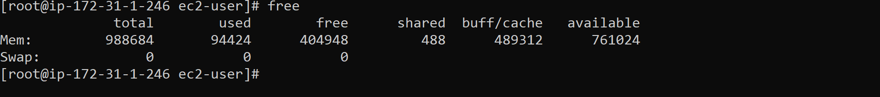



**Rsync** copies files and has a **-P** switch for a progress bar. So if you have rsync installed, you could use a simple alias.

alias cp='rsync -aP'

nano text editor

Ctrl+x and enter to exit

TOP command

Display the process of the cpu

W command

**uptime** and **who** commands given one immediately after the other, in that order.

**Command:talk**

An enhancement to **write** command, **talk** command lets you talk to the logged in users.

### 47. command: mesg

Lets you control if people can use the “**write**” command, to send text to you over the screen.

Command: write

Let you send text directly to the screen of another Linux machine if ‘**mesg**’ is ‘**y**’.

### Command: wall

one of the most important command for administrator, **wall** sends a message to everybody logged in with their **mesg** permission set to “**yes**“.

Command Uptime

 you could run **uptime** to verify what happened actually when the server was unattended.

Command Dig

**dig** is a tool for querying **DNS** nameservers for information about host addresses, mail exchanges, nameservers, and related information.

Command Nslookup

A network utility program used to obtain information about Internet servers. As its name suggests, the utility finds name server information for domains by querying **DNS**.

For query name server

For mail exchanger type=mx

Name server type=ns

### 42. Command: netstat

**netstat** command displays various network related information such as network connections, routing tables, interface statistics, masquerade connections, multicast memberships etc..,

list off network port -a

list of all tcp ports -at

show statistics of all ports -s

listing all udp port conn. -au

listning connection -l

**Command ifconfig**

**ifconfig** is used to configure the kernel-resident network interfaces. It is used at boot time to set up interfaces as necessary. After that, it is usually only needed when debugging or when system tuning is needed.

Command grep

1. Search any line that contains the word in filename on Linux:  
   **grep 'word' filename**
2. Perform a case-insensitive search for the word ‘bar’ in Linux and Unix:  
   **grep -i 'bar' file1**
3. Look for all files in the current directory and in all of its subdirectories in Linux for the word ‘httpd’:  
   **grep -R 'httpd' .**
4. Search and display the total number of times that the string ‘nixcraft’ appears in a file named frontpage.md:  
   **grep -c 'nixcraft' frontpage.md**

Command pip

It is used for package installer for phyton

Command curl

Command apt

Command sed

Command unzip